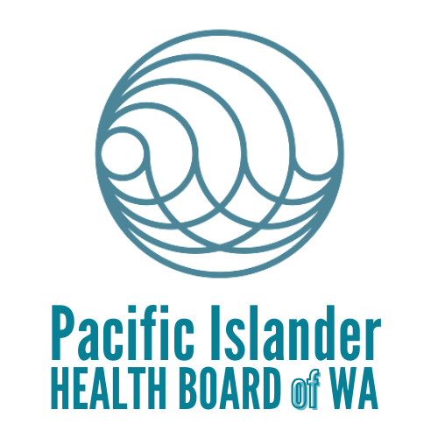
CBO Workshop
August 03, 2022

Agenda

- Welcome and Introductions
  - Rensa (with introductions in the comments section encouraged for attendees)

- PIHB Team introductions
  - Team will introduce themselves in their respective languages.

- Updates from PIHB about the second quarter of work in 2022
  - In-depth presentation on education event that we have been putting on: content, attendance, lessons learned from the process

4.Workshop topic - Outreach and Education with panel
  - What does it look like to do in-person, hybrid, and virtual events well?
  - What draws in community to enrollment events (special activities, giveaways, etc.)
  - Building relationships and trust with the community - how do we do that with leaders? Who are we missing here?
  - How do we help educate the community on what is available to them, and what are the gaps in learning?

- Updates from HCA
  - After-Pregnancy coverage

6. BSK
- Presentation on the work they do and programs they have for the community.

7. PIHB Youth program
a. Presentation on Behavioral Health

8. Updates from CBOs
a. MIC Oregon – Bri Borja
b. Better Health Together - Carlinda

9. Open discussion
  - How do we feel about outreach now, what is working well and what isn’t working?
  - Especially for our leaders and CBOs, what do you think community still needs to help understand about Apple Health, COFA Islander Programs, Qualified Health Plans? How can PIHB address these needs?
  - Any community events coming up?

8. End of workshop

(The panel will consist of Rensa Mailo, Cyril Gorongayin, Clara Moonfell, Alinda Alik, Esther DeBrum, LeChante Raiwalui, Devi Midaliar and La’i King.)

